**C语言三层电梯状态机课程设计报告**

**张鹏 16040310035**

**状态机图**

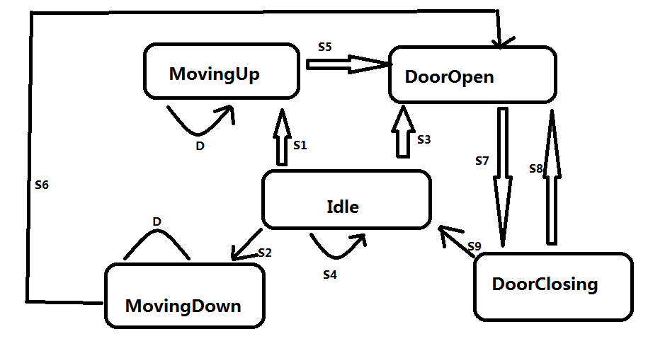

**此电梯可以分为五种状态：**

1. **Idle : 待机状态**
2. **MovingUp : 上升状态**
3. **Movingown : 下降状态**
4. **DoorOpen :开门状态**
5. **Doorlosing : 关门状态**

**此电梯的事件：**

**Events：**

**E1: 门内开门按钮(OpenDoorLight)**

**E2: 门内关门按钮(CloseDoorLight)**

**E3: 门内楼层按钮(PanelFloorLight)**

**E4: 门外up呼叫按钮(Call Light)**

**E5: 门外down呼叫按钮(Call Light)**

**每个状态对应状态函数，所检查的事件，执行的动作（即出弧标识），状态变迁，整理如下表**

|  |  |  |
| --- | --- | --- |
| **状态常数** | **状态函数** | **检查事件，执行事件，执行动作，状态变迁** |
| **Idle** | **StateIdle** | **S1,S2,S3,S4** |
| **MovingUp** | **StateMovingUp** | **S5,D** |
| **MovingDown** | **StateMovingDown** | **S6,D** |
| **DoorOpen** | **StateDoorOpen** | **S7** |
| **DoorClosing** | **StateDoorClosing** | **S8,S9** |

**各个状态函数描述整理见下表**

|  |  |
| --- | --- |
| **S1** | **检查E3，E4，E5事件 if(floor > 0 && up)** |
| **S2** | **检查E3，E4,E5事件 if(floor > 0 && !up)** |
| **S3** | **检查E1事件if(GetOpenDoorLight())检查E1事件**  **检查E4/E5事件if (GetOpenDoorLight())else if (GetCallLight(GetNearestFloor(), true) || GetCallLight( GetNearestFloor(), false))** |
| **S4** | **检查E2事件if(GetCloseDoorLight())** |
| **S5** | **检查E3、E4、E5事件if (fabs(GetFloor() - floor) < Lib_FloorTolerance)** |
| **S6** | **检查E3、E4、E5事件if (fabs(GetFloor() - floor) < Lib_FloorTolerance)** |
| **S7** | **检查E2事件if (GetCloseDoorLight()||IsDoorOpen(floor)) if(IsDoorOpen()) 检查E1事件if（GetOpenDoorLight()）** |
| **S8** | **检查E1事件if (GetOpenDoorLight())检查E2事件if(GetCloseDoorLight()) if (IsBeamBroken())** |
| **S9** | **if (IsDoorClosed(floor))；进入Idle** |
| **D** | **检查E1、E2事件if(GetOpenDoorLight()/GetCloseDoorLight()) if(SetOpenDoorLight()/SetCloseDoorlight())** |